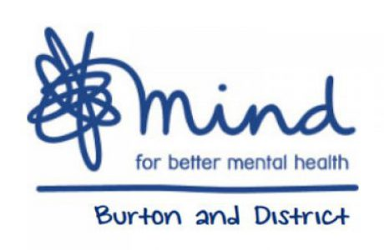

Can you help make a difference?
Did you know that 1 in 4 people will suffer from mental health problems at some point in their lives?
Burton and District Mind has been helping people with mental health problems for over 25 years. Locally based in Burton on Trent they work throughout East Staffordshire with help from a wide range of local statutory and voluntary organisations.
Every year this small local charity helps hundreds of local people through some of the most difficult times in their lives. Led by a small number of voluntary unpaid Trustees, they are passionate about improving the mental health of local people.
Burton and District Mind are now looking to strengthen their Board of Trustees and are looking for local people who want to help them make an even greater impact
They are particularly looking for local people with financial skills and those with experience of fundraising and making successful grant applications. People with lived experience of mental health problems and those from under represented communities are especially welcomed.
Trustee Chairman, Ken Builth says ‘These are challenging times for everyone, so it’s not surprising that many people find it difficult to cope. Anyone can suffer mental health problems, at any age and from any background.
Burton and District Mind is passionate about helping local people with mental health problems. We have already achieved a great deal, but we want to do even more. This is difficult with the impact of austerity cuts hitting the voluntary sector hard, but we have a great team and are constantly finding new ways of rising to the challenge.
We want to hear from local people who are concerned about mental health and have an evening or more a month to spare to join our Board of Trustees. The role is voluntary and unpaid, but it is a great opportunity to give something back to the local community’.
If you are interested in finding out more, please email info@burtonmind.co.uk or contact Tel 01283 566696.

